7th February 2024
Peter van Roden - Senior Vice president, Warner Bros. Themed Entertainment
Tara Smith - Executive Vice President & Corporate Secretary, Global Head of ESG, Warner Bros. Discovery
Andrew Bromell - Vice President at Warner Bros. Discovery Global Consumer Products – ANZ
Nicole Hardiman – Senior Manager – Retail, Marketing and Communications, Warner Bros. Discovery Consumer Products (ANZ)
WBD Ethics Team
Dear Sirs/Mesdames
Ref: Harry Potter: A Forbidden Forest Experience Relocation
I write to you in support of Save Briars Sanctuary, a community campaign to have the Harry Potter: A Forbidden Forest Experience relocated from The Wildlife Sanctuary in The Briars, Mount Martha, Australia to a suitable location.
Along with many others, some of whom have already requested refunds on their tickets, I was shocked to discover that the event will not be held in “a beautiful woodland” (an unusual descriptor for a fragile Australian scrubland) as advertised by your partner, Fever, on their website. It is to be held instead in our precious Wildlife Sanctuary – an area that is surrounded by an electric fence to protect the thousands of native animals who live there peacefully and naturally. The opaqueness of the nature of the location in your advertising, however, offers the opportunity to relocate the event outside the Sanctuary to another area of The Briars without reworking your publicity.
The Briars is a large property that hosts many events - from outdoor cinemas to music concerts - but never would those that know the offerings of the location envisage that the Sanctuary would be chosen for the Harry Potter event. An event of four months duration with up to 200,000 people traipsing the trails among nocturnal wildlife is unimaginable in this tranquil, protected space.
Further, our councillors and council staff are fast losing their credibility with our community regarding their promise of transparency, accountability, and care for the environment, having finalised a contract with the event partners which is in its entirety covered by a non-disclosure agreement. We, their constituents, were not privy to even the high-level due diligence assessment and mitigation report until the council meeting on 6th February, nor how you intend to ameliorate the sort of harm done that was documented when the same event was previously held in Brussels.
We call into question your stated positions on the quadruple bottom line, in particular, care for the environment and community:
- Your social impact statement seeks to assure your stakeholders that you advocate for action on the issues that are important to your customers.
Biodiversity and the protection of the local, precious ecosystems are important to us here in Australia. Our ecologies are fragile. The Briars Sanctuary has been nurtured not just by the resources of the local government but decades of volunteer work and care: social clubs have built the fences; generations of children have planted trees; wildlife carers have released their rescued wildlife into this habitat. We know these animals and their history and have provided them with a safe place, or so we thought.
- You talk of the values of culture, connection and community.
The Briars Sanctuary is a special place, especially to the local Mornington Peninsula community. It is also a significant Aboriginal Cultural Heritage site. It holds for us social capital, spiritual capital, natural capital and much more.
By engaging your employees and your business in the violation of a sanctuary that was believed to be a safe haven for our local indigenous wildlife, you are taking something precious away from a thriving community, detracting from the sacred nature of this land that has cultural, ecological and historical connection. By locating the Harry Potter: A Forbidden Forest Experience in this special place, you undermine any trust the residents have in the ability of the local government and its officers to protect our ecosystems from commercial plunder.
- You speak of employee-facing campaigns, to enable staff to give back to their communities in the way that matters to them and to respond to disasters and crises.
Yet, your actions in designing commercial in confidence contracts undermine the agency of staff at The Briars and at the council from speaking out and acting to protect the flora and fauna in the location of the event and to be true to their professional ethics. It has been said that Sanctuary staff have already started resigning or taking leave due to the distress caused by these circumstances.
Then there are your ESG responsibilities:
- You aim to do well as a business and to do good as members of communities around the world.
The Save Briars Sanctuary campaign has garnered over 20,500 online signatures (in just over one month) calling for the event to be relocated, as your choice of location goes against the ethos of the Sanctuary’s mission. We love the idea of the event itself but are appalled at the thought of it being held in a space set aside for conservation and protection.
- You purport to “participate in sustainable practices…to lessen the environmental footprint of [your] productions worldwide.”
You, however, only describe five key areas related to cost, waste management and emissions reduction - indicative of minimal environmental efforts of a company in the early stages of its sustainability development. You speak of mitigation and minimisation of harm to the natural environment. Your choice of the Sanctuary as your location indicates this is in fact not a priority of Warner Bros. Mitigation and minimisation is only an appropriate strategy when harm cannot be avoided in the first instance. As an operator in our part of the world, you will actively increase Warner Bros. Discovery’s environmental footprint by irrevocably damaging our Sanctuary.
There are numerous suitable locations on the Mornington Peninsula for this fabulous event. The Briars Sanctuary is not one of them.
We entreat you to consider your good name, and in the interests of the communities for which you state you will do good, work with your partners on this project to

Relocate the Harry Potter: A Forbidden Forest Experience out of The Briars Sanctuary.

Yours sincerely,
Louise Page, Spokesperson
Dr Leanda Care, Secretary
www.savebriarssanctuary.com
Attachments: Statements of Support
STATEMENTS OF SUPPORT:
Parliamentary Representatives:
Deputy Leader of the Victorian Greens, Ellen Sandell, Member of Parliament for Melbourne
Chris Crewther, Member of Parliament for Mornington.
Organisations:
AWARE (Australian Wildlife Assistance Rescue & Education), have been rescuing and rehabilitating wildlife regionally since 2005. We support ‘Save the Briars Sanctuary’ stand that a wildlife sanctuary is an inappropriate location for the Warner Bros. Discovery Global Themed Entertainment, Fever and IMG. Harry Potter Forbidden Forest Experience.
The lights, sounds, and smell of the special effects along with thousands of people entering the fenced sanctuary will have a profound and lasting detrimental impact on the wildlife we should be able to reasonably expect be protected in a ‘sanctuary’.
We are also concerned that the community was not consulted or given the opportunity to provide feed-back, that the environmental impact study is not available for viewing and that the whole process appears to have been done in haste. As a minimum we would expect an environmental impact study to cover 12 months and to include community feedback.
AWARE stand with many other concerned individuals and groups in condemning this event being held in the Briars Sanctuary. All wildlife deserve to be protected from the fear, the loss of breeding, foraging and hunting opportunities, that an event like this will inflict on them. An alternative venue, such as the Scout Park in Mount Martha, would be less destructive to biodiversity.
We expect those such as Councils entrusted with the care of the environment and welfare of wildlife to act in their best interests and not be motivated by just financial gain. Our sanctuaries should never be turned into theme and amusement parks, wildlife deserve our protection and respect.
AWARE is 100% volunteer with DGR Status
24 Hour Hotline 0412 433727
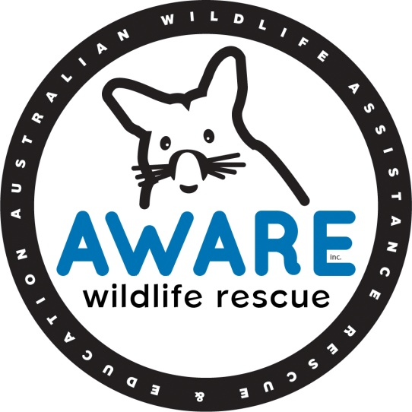

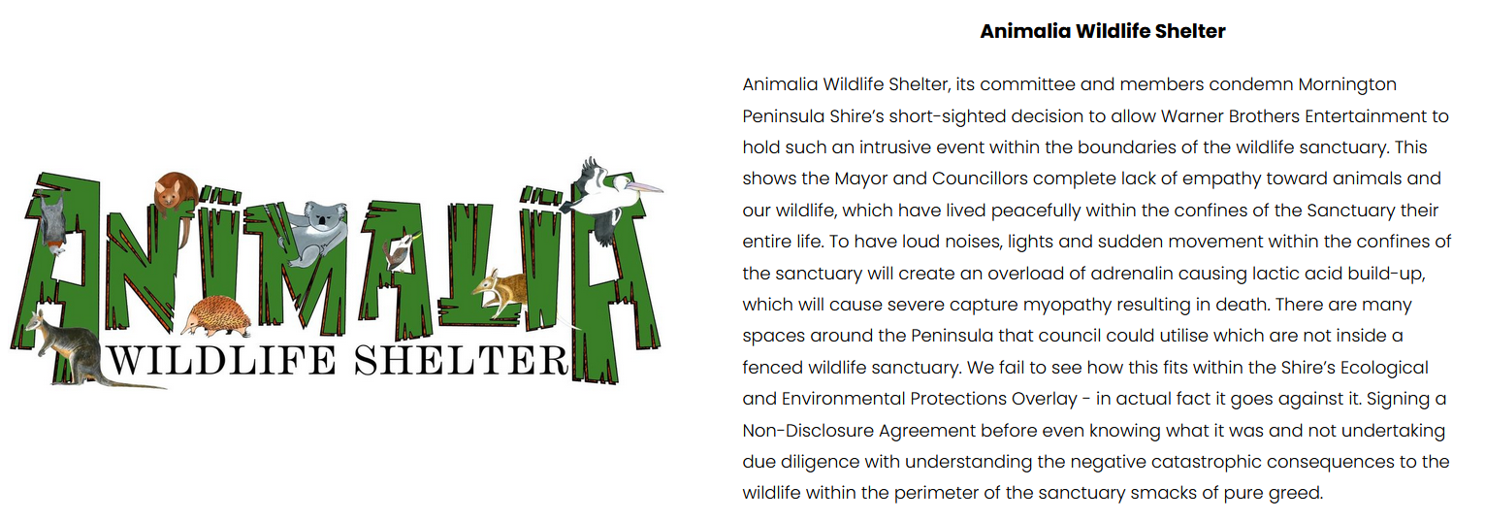
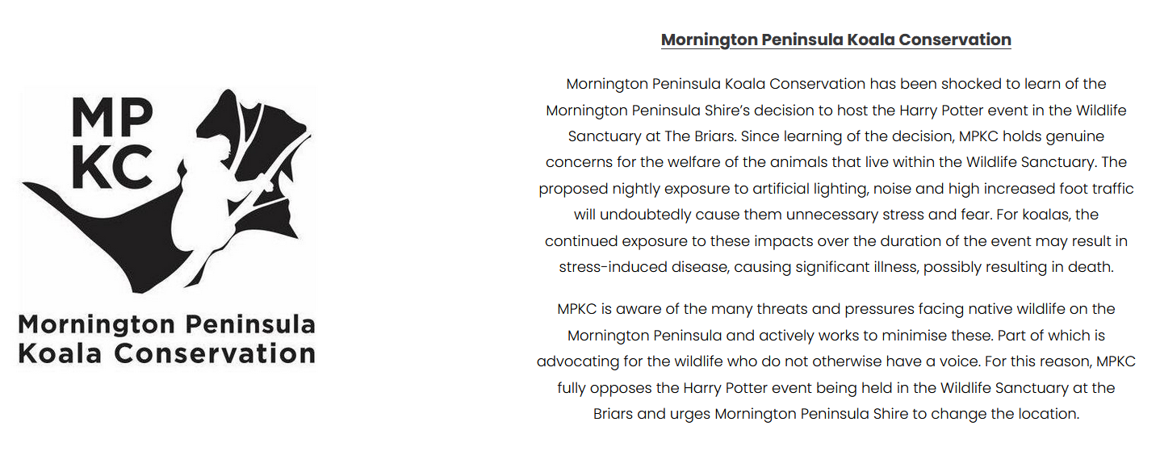

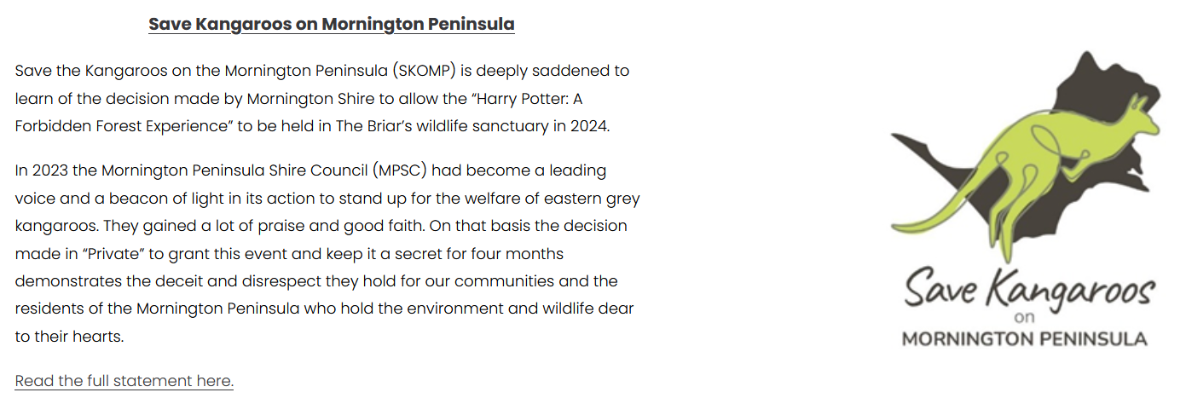

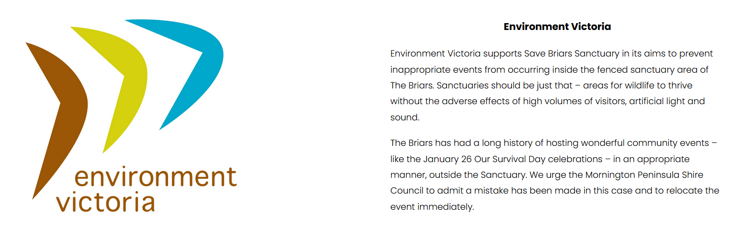

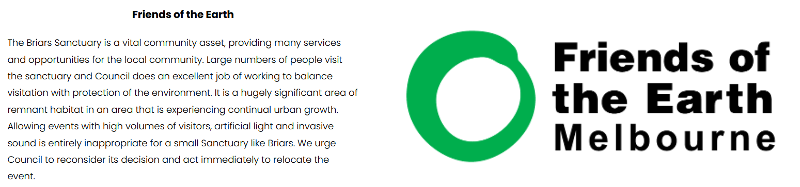

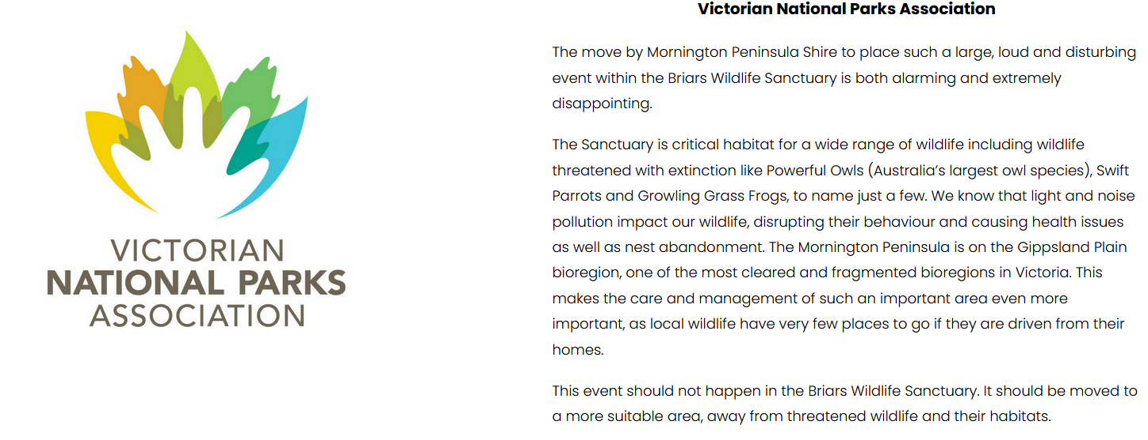
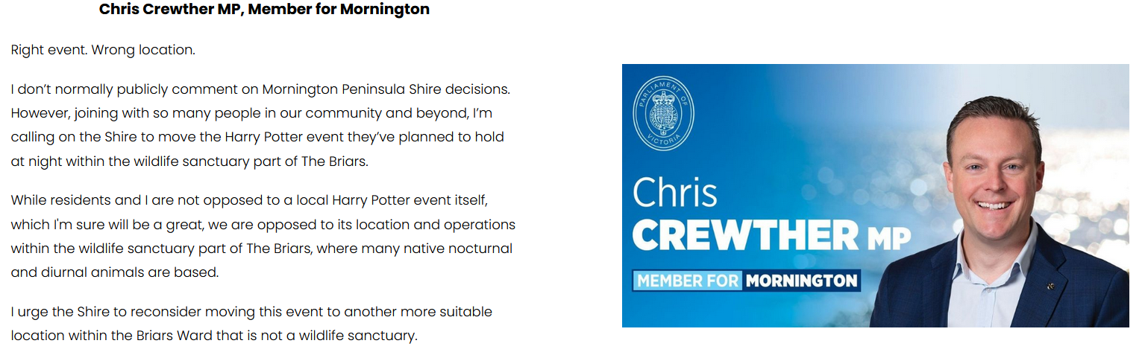
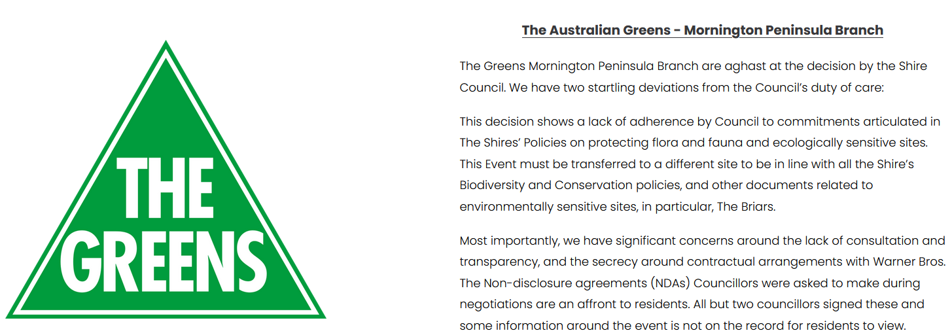

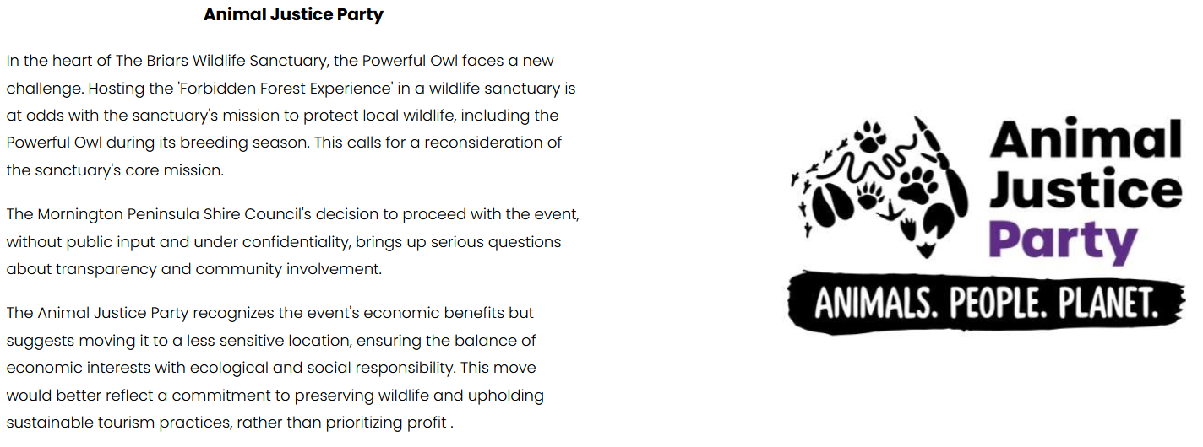
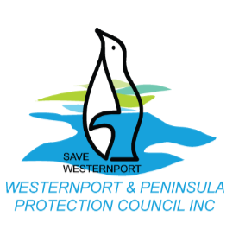
Westernport and Peninsula Protection Council Inc believes that The Harry Potter Event should be moved from inside the fenced wildlife sanctuary at The Briars. There has been a misunderstanding of the importance of the sanctuary, and therefore a reassessment of the agreement is needed. We expect that The Mornington Peninsula Shire and Warner Bros to undertake this re-assessment.
This fenced area has significant fauna that one day could be reintroduced to other parts of the region. The sanctuary is part of a biolink that one day may have fauna from this sanctuary. It is a place of great hope and ecological importance. A lot of money and passion has been spent on increasing the biodiversity of this area.
There are other areas even at The Briars, that would be more suitable for large groups of humans, noise and lights, but not in this wildlife sanctuary.

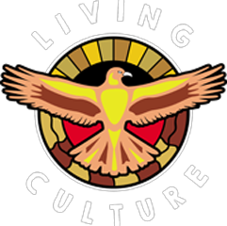
Lionel Lauch & Heidi Duell Founders of Living Culture strongly object to the Harry Potter Forbidden Forest Experience being held in The Briars Sanctuary. A sanctuary by its definition is a safe space free from danger.
Living Culture are a respected Indigenous led Cultural engagement organisation based on Bunurong land on the Southern Mornington Peninsula who have and do work extensively with the Briars for over a decade.
This site is protects significant cultural & environmental locations and flora & fauna.
We are distressed a decision was made to hold this event at this site, and with the lack of communication & community consultation.
Lionel Lauch & Heidi Duell

Video Statements:
Rosie Batty, AO – Australian of the Year 2015. Domestic Violence Campaigner
https://www.facebook.com/reel/2104165649931943
Sean Wilmore – former Ranger at The Briars. Founder, Thin Green Line Foundation.
https://www.facebook.com/reel/274118009023194

